**ERD Diagram**

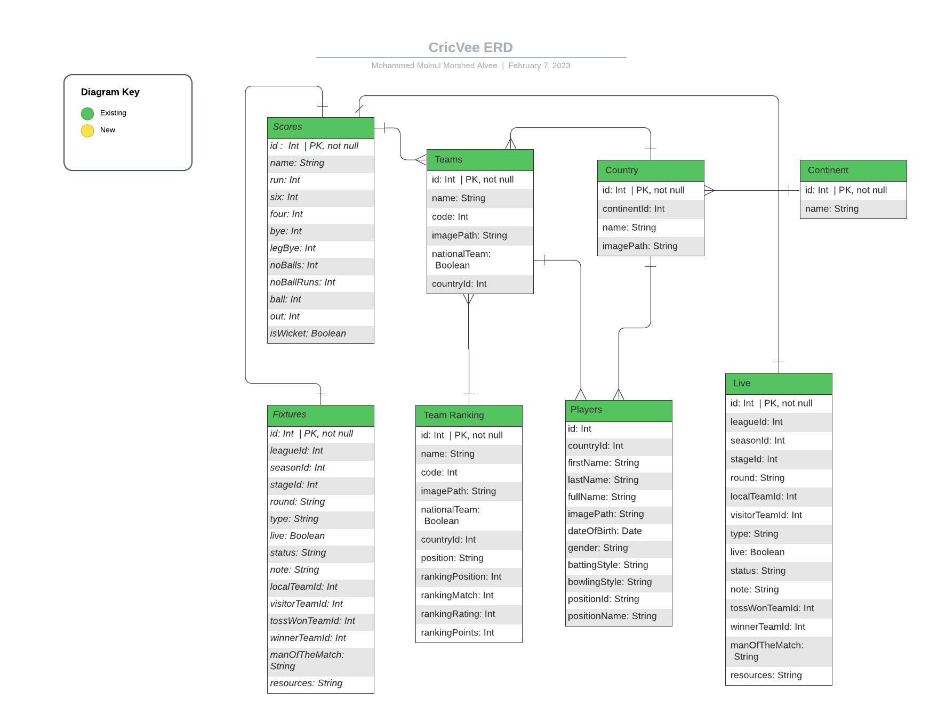

**Data Flow Diagram**

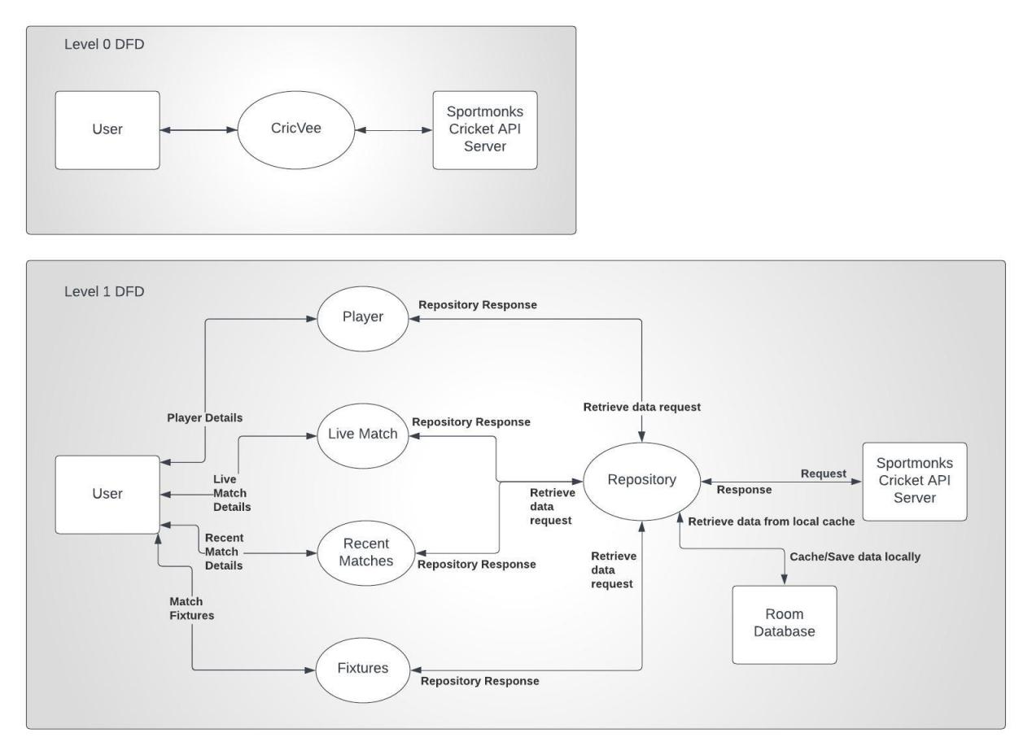

**Live Score Sequence Diagram**

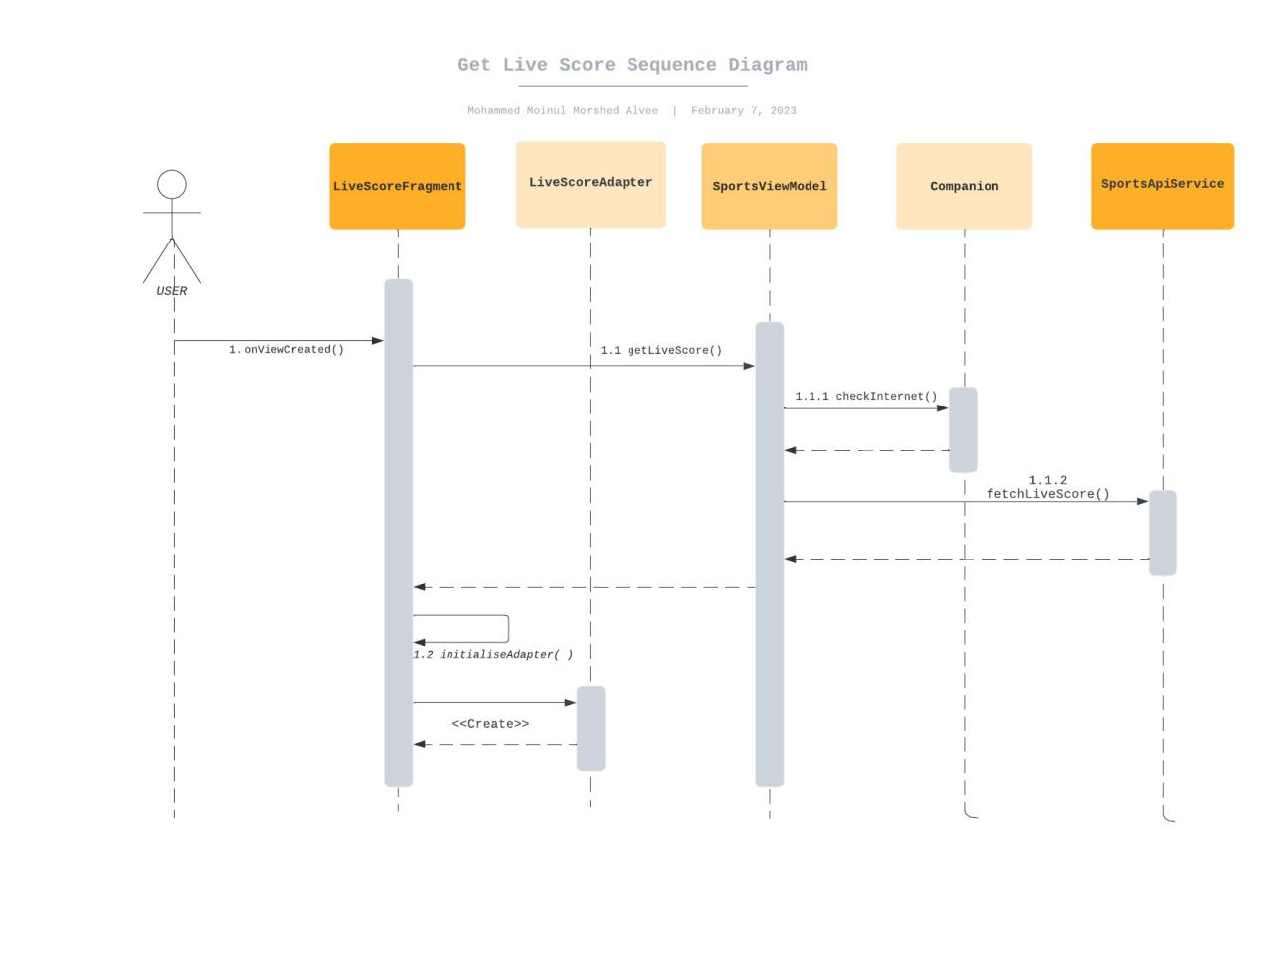

**Match Details Sequence Diagram**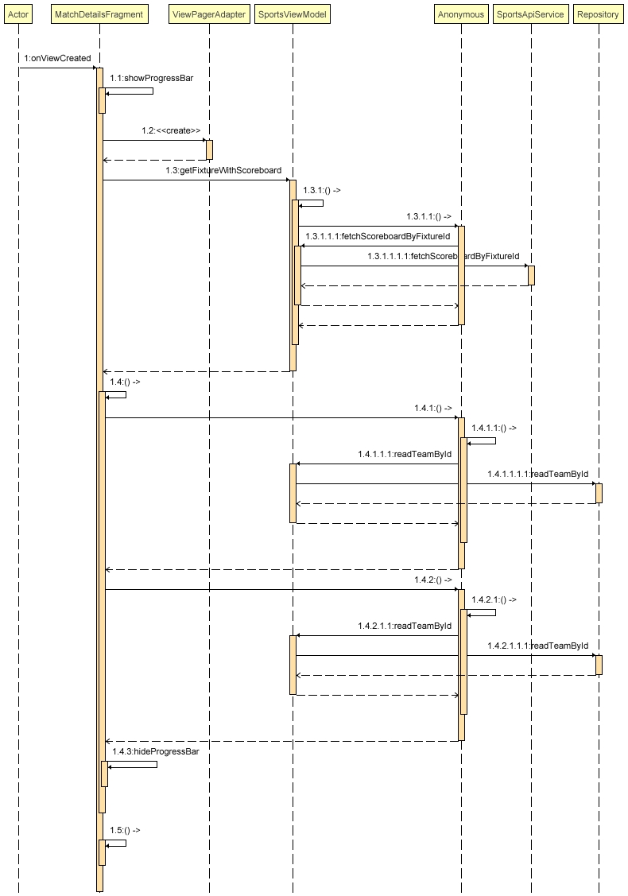

**Match Summary Sequence Diagram**

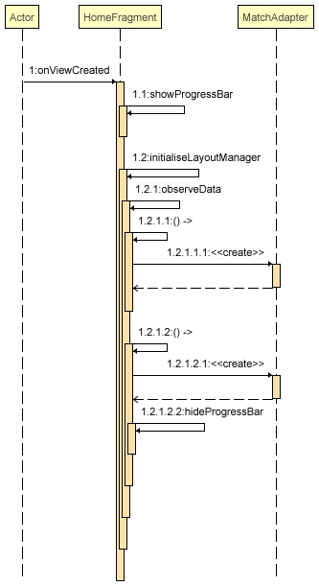

**Tournament Fixture Sequence Diagram**

